**COMSATS UNIVERSITY ISLAMABAD**



**Software Testing (CSE-455)**

**Lab 4**

|  |  |
| --- | --- |
| **Name:** | **Muaaz Bin Mukhtar** |
| **Reg No:** | **FA21-BSE-045** |
| **Class & Section:** | **BSE-7A** |
| **Instructor:** | **Mam Najmun Nisa** |
| **Date:** | **October 1, 2024** |

**Department of Computer Science**

**Backlog:**

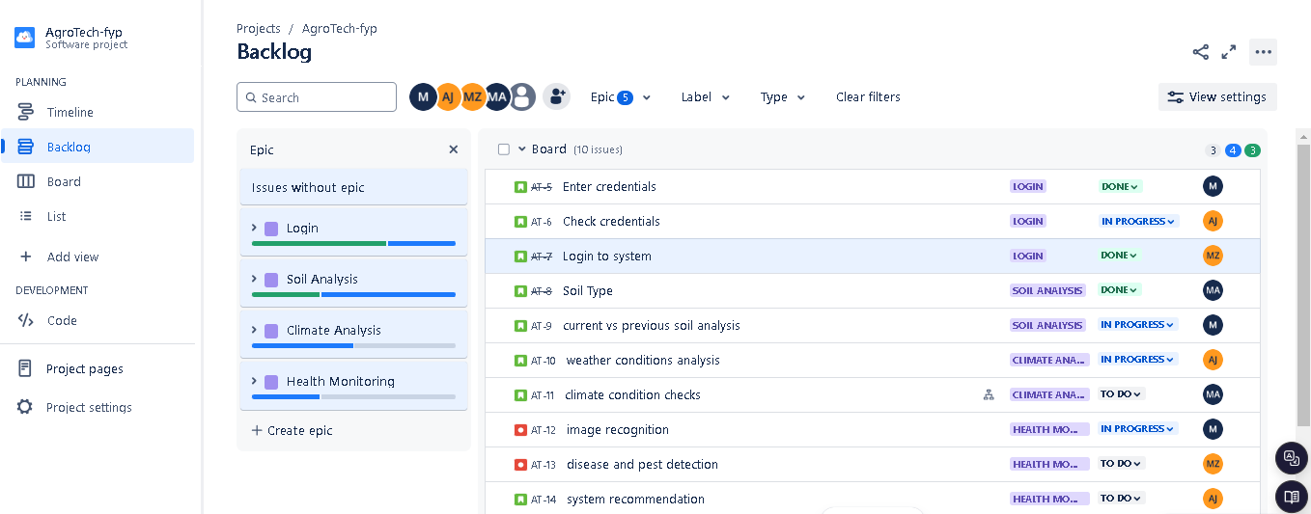

**Kanban Board:**

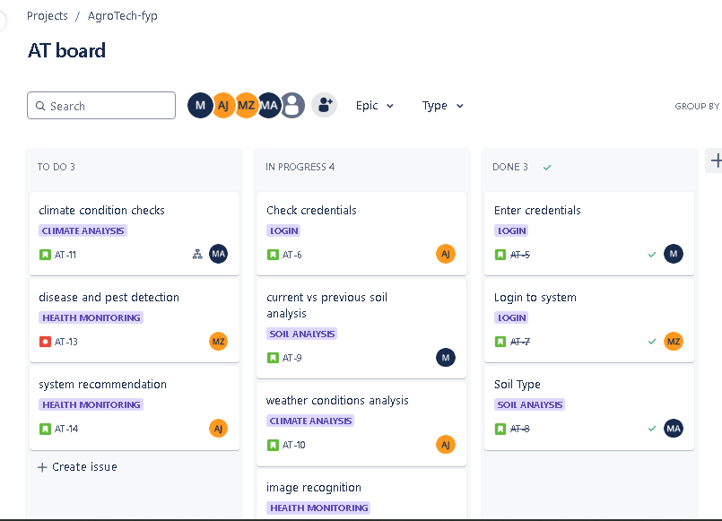

**Report:**

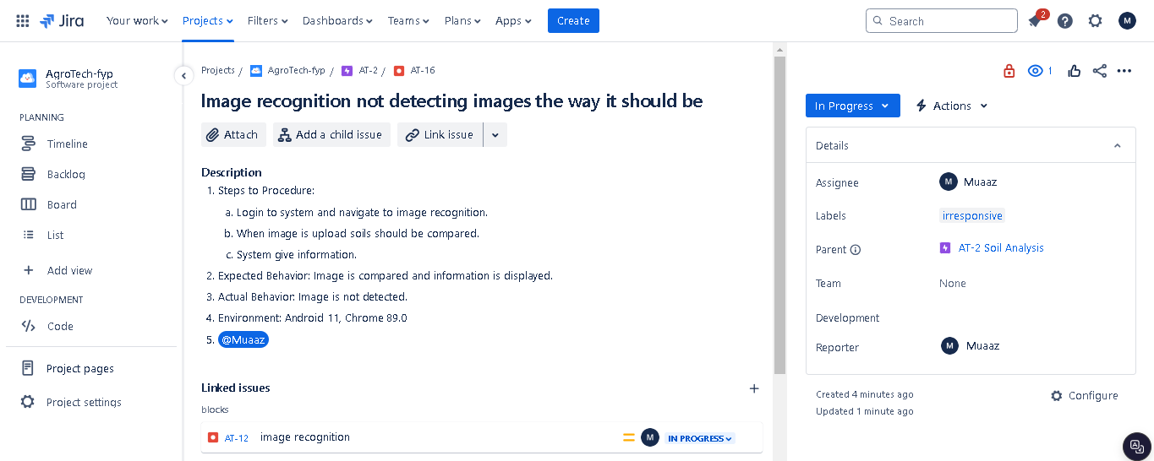

**Comment:**

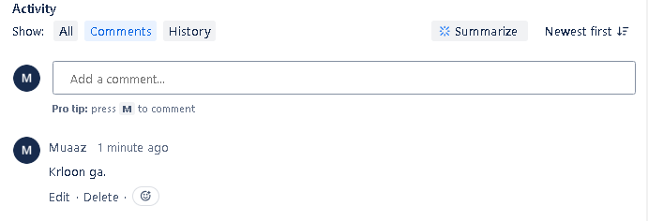

**Filter:**

